Assignment #8
GUI Layout:
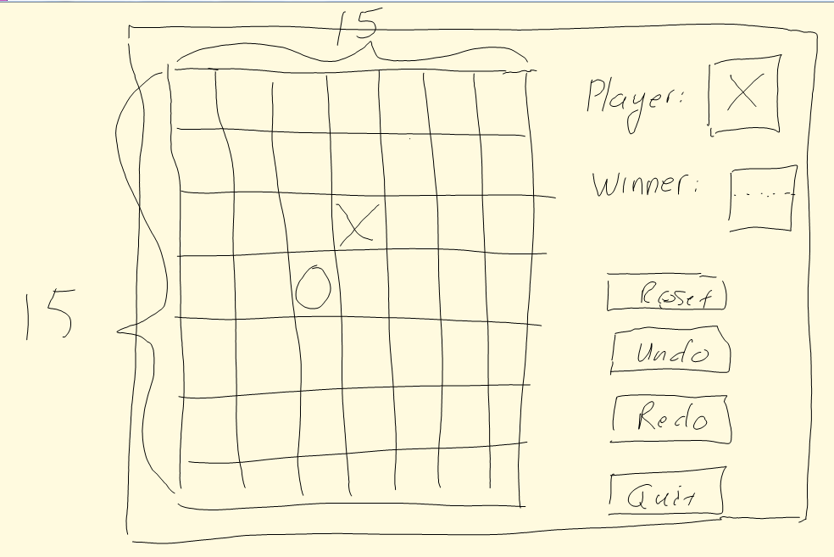
GUI components:
- Buttons for game board cell layout.
  - Use images for black and white stones (might be of size 32x32 pixels)
- 1 label for showing current player’s turn. Font size regular, black color.
- 1 label for showing who is the winner or other game status. Font size large, red color.
- 4 buttons for reset, undo, redo, and quit game.
- I will use grid to layout the game board.
Event Model:
Game board:
- I will use command parameter because I use buttons for game cell layout and one even handler for all cells.
- Each game cell layout button will have a text field with number from 1 to 15x15, same color as cell background to make it invisible. These will be used as their id to distinguish each inside the event handler.
- Game cell button will be disabled with an image of black/white stone (depends on which player’s turn) after a player click on it so we don’t need to handle any unnecessary event.
Game control buttons:
- Use the same click event handler for the 4 buttons (reset, undo, redo, and quit buttons). Distinguish them by using each one’s text label.
Labels:
- No event handler for the 2 labels.
Data Structures:
- Will use data structure list because we need to edit it during game.
- 1 of two dimension list (15x15) for storing each cell’s status like which stone is in which cell for game winner checking purposes.
- 1 list for storing each player’s move so player could undo or redo.
Game Logic:
- Each time a player place their stone on a cell, check the surrounding of that cell with radius of 5 cells. If there is a consecutive of 5 stones of the current player, he’s the winner.
- Winner is shown using label.
- Use one variable for the index to the list of history moves. Index decrease for undo to access the last move. Index is increased for redo to get back to the last undo. Those two depends on where the index is in the list.

